1. use faculty;

Select * from facultydetails where faculty_email=null;

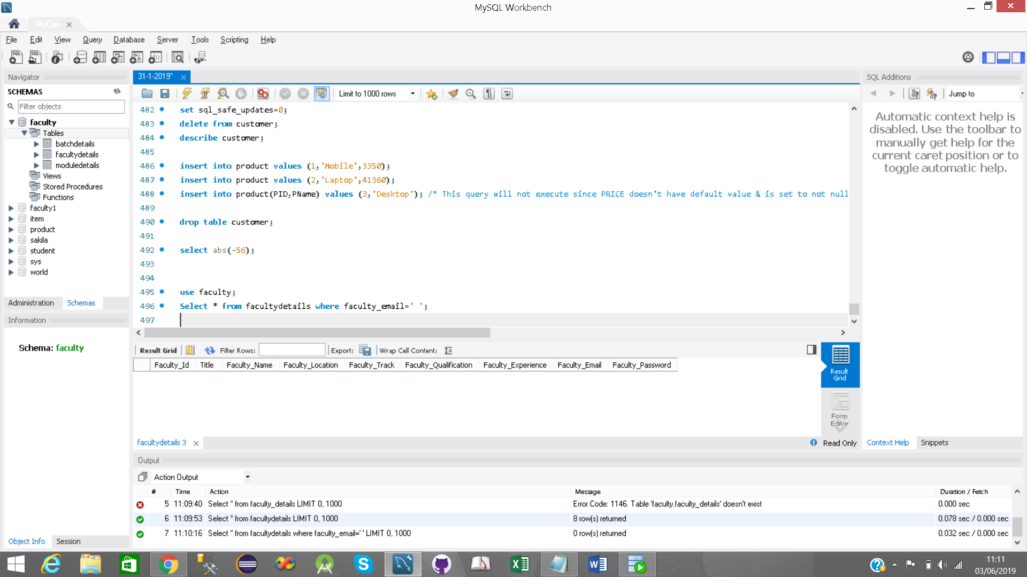

2)

Select faculty_id,faculty_name,faculty_track,faculty_location from facultydetails where faculty_experience>4;

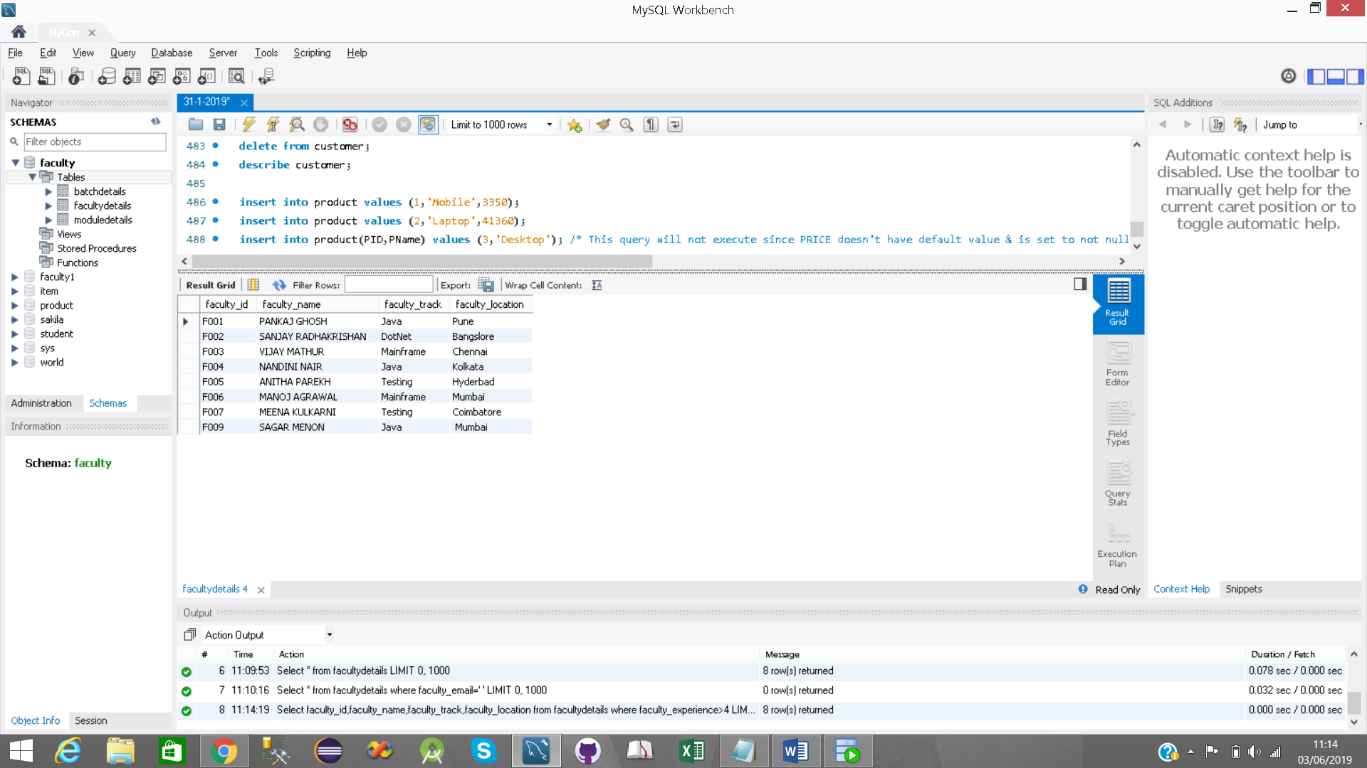

3)

Select * from moduledetails where module_duration>150;

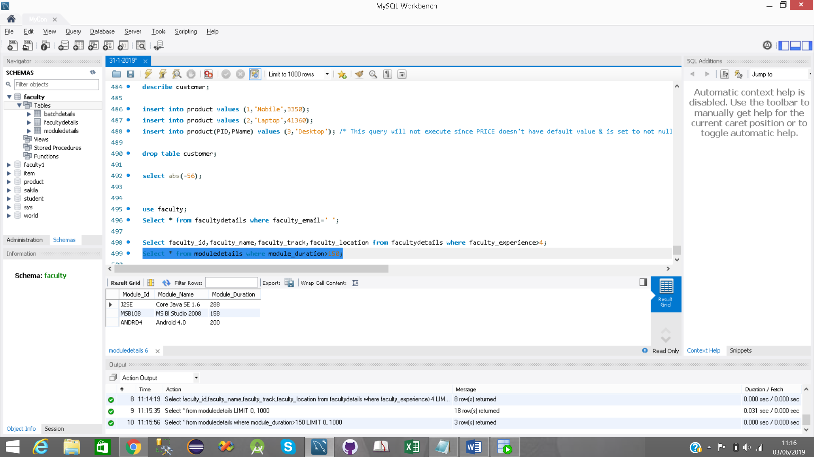

4)

Select faculty_id,faculty_name from facultydetails where faculty_qualification<>'Bachelor of Technology';

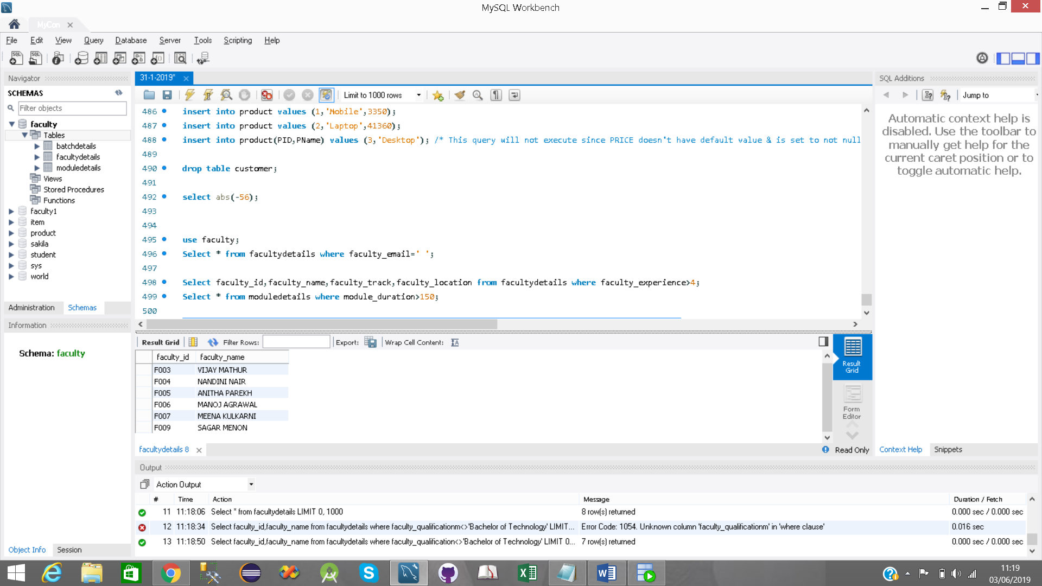

5)

Select * from moduledetails where module_duration>=100 and module_duration<=200;

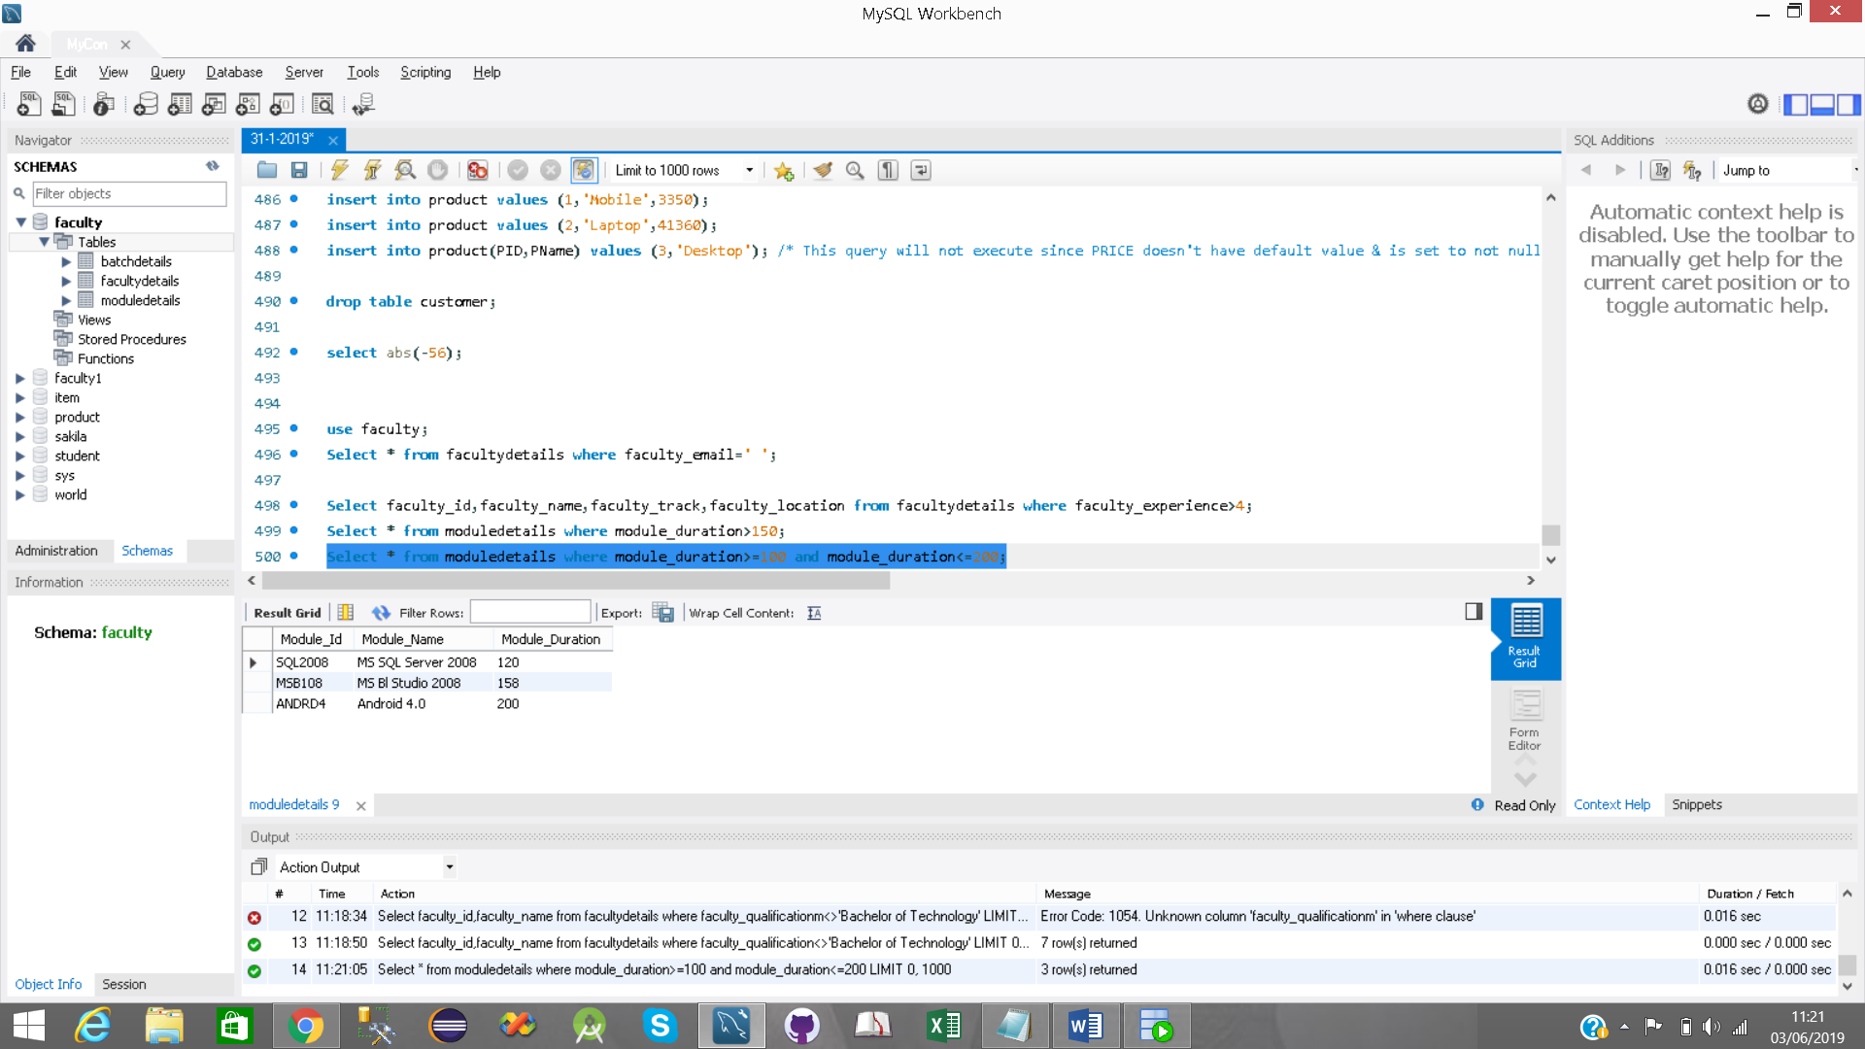

6)

Select faculty_id,faculty_name from facultydetails where faculty_name like 'A%';

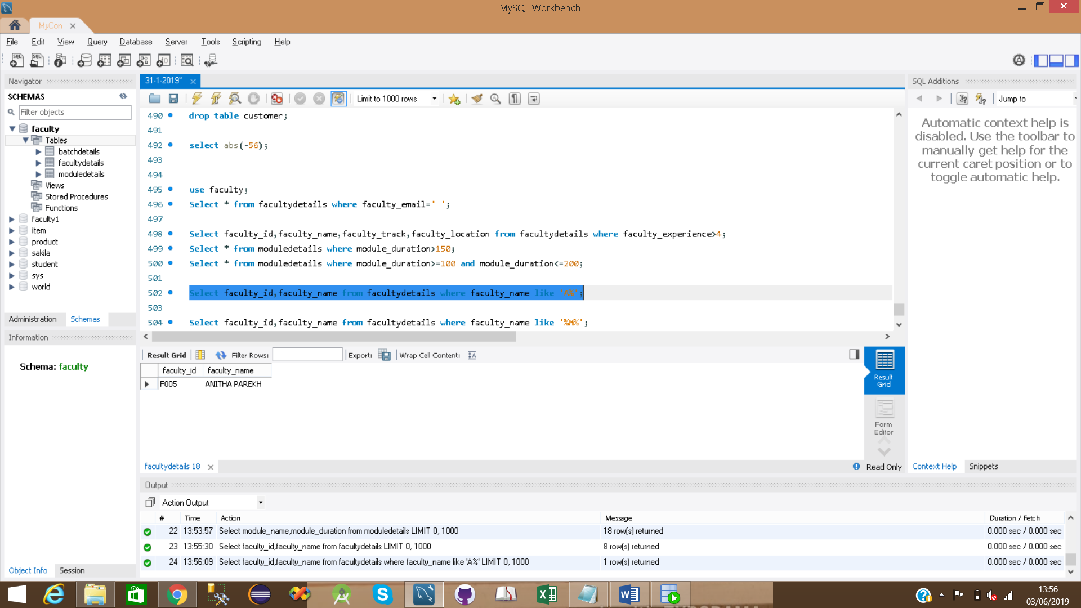

7)

Select faculty_id,faculty_name from facultydetails where faculty_name like '%M%';

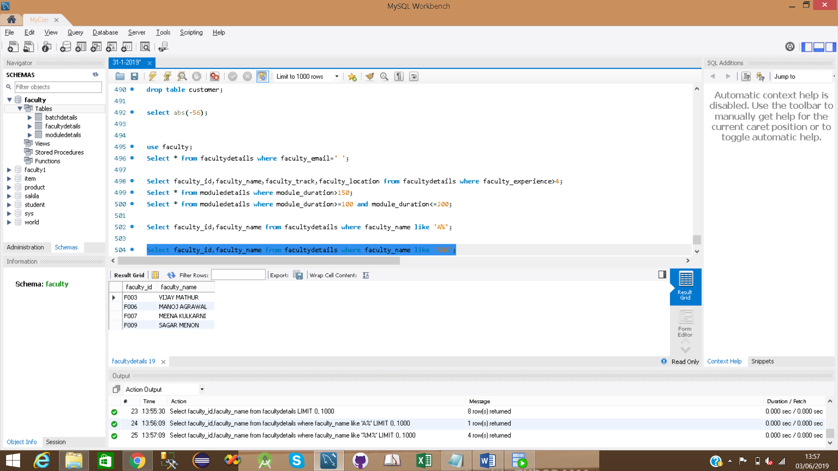

8)

Select * from moduledetails where module_name =null;

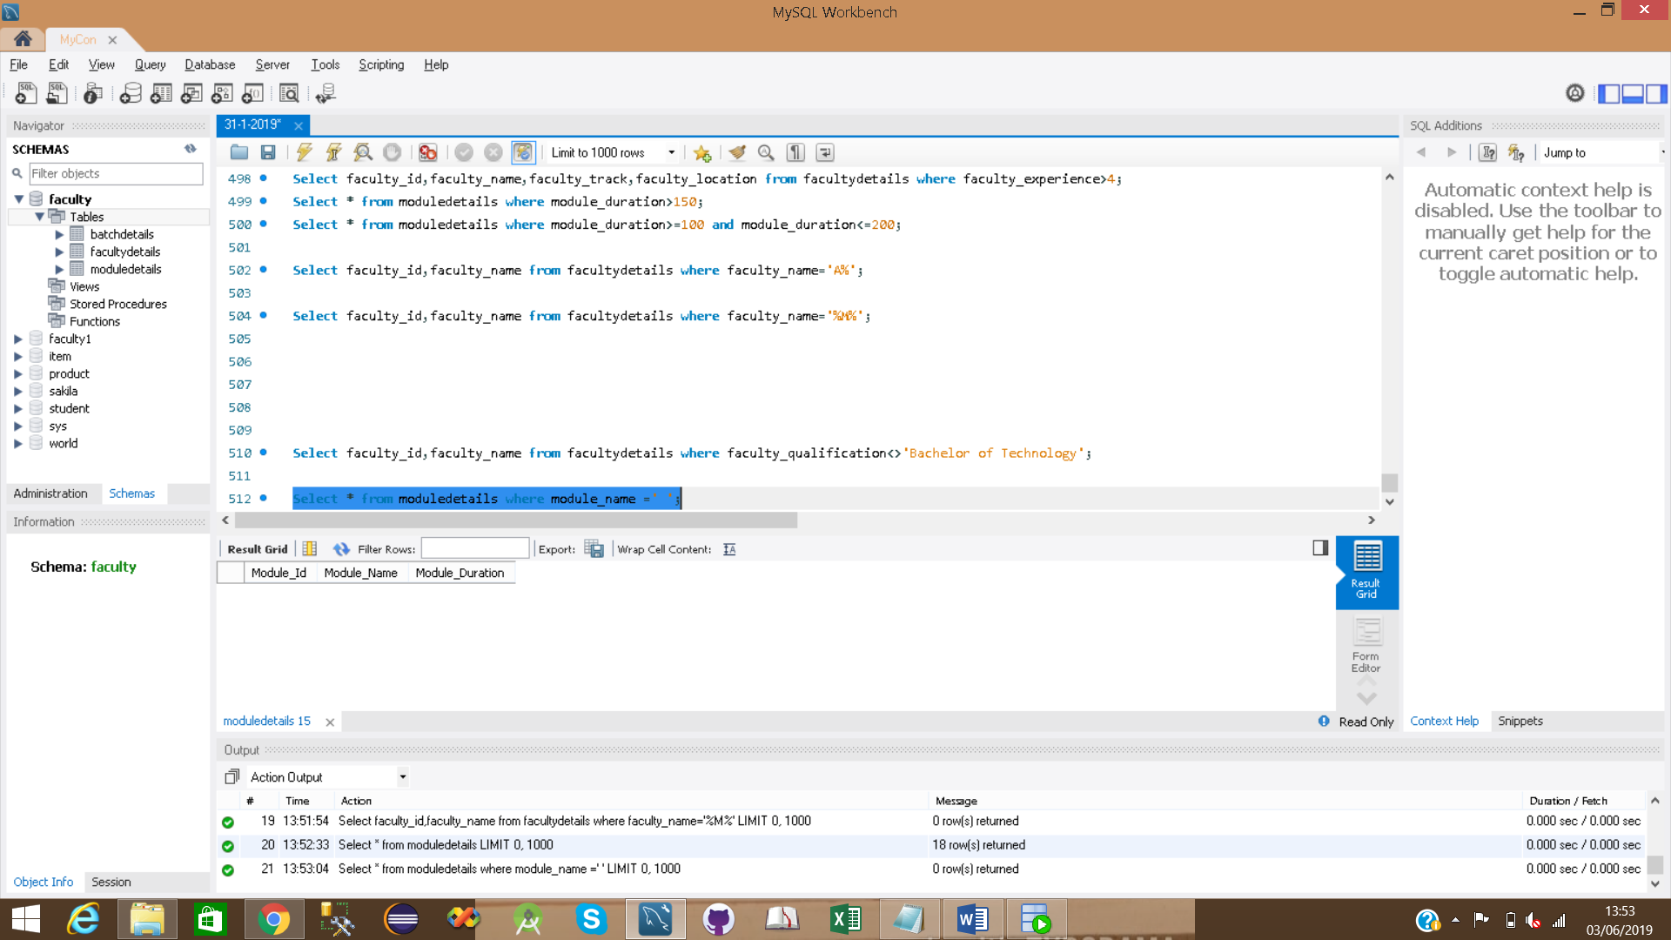

9)

Select module_name,module_duration from moduledetails ;

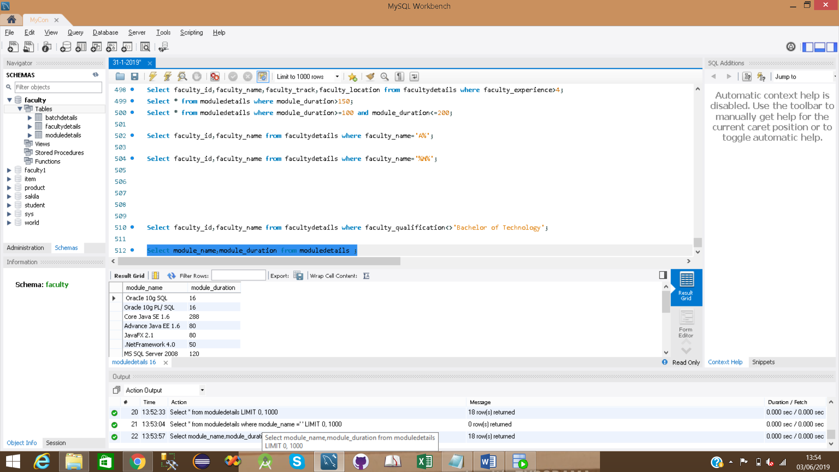

10)

Select module_id, module_name from moduledetails where module_name regexp binary '^[A-Z]';

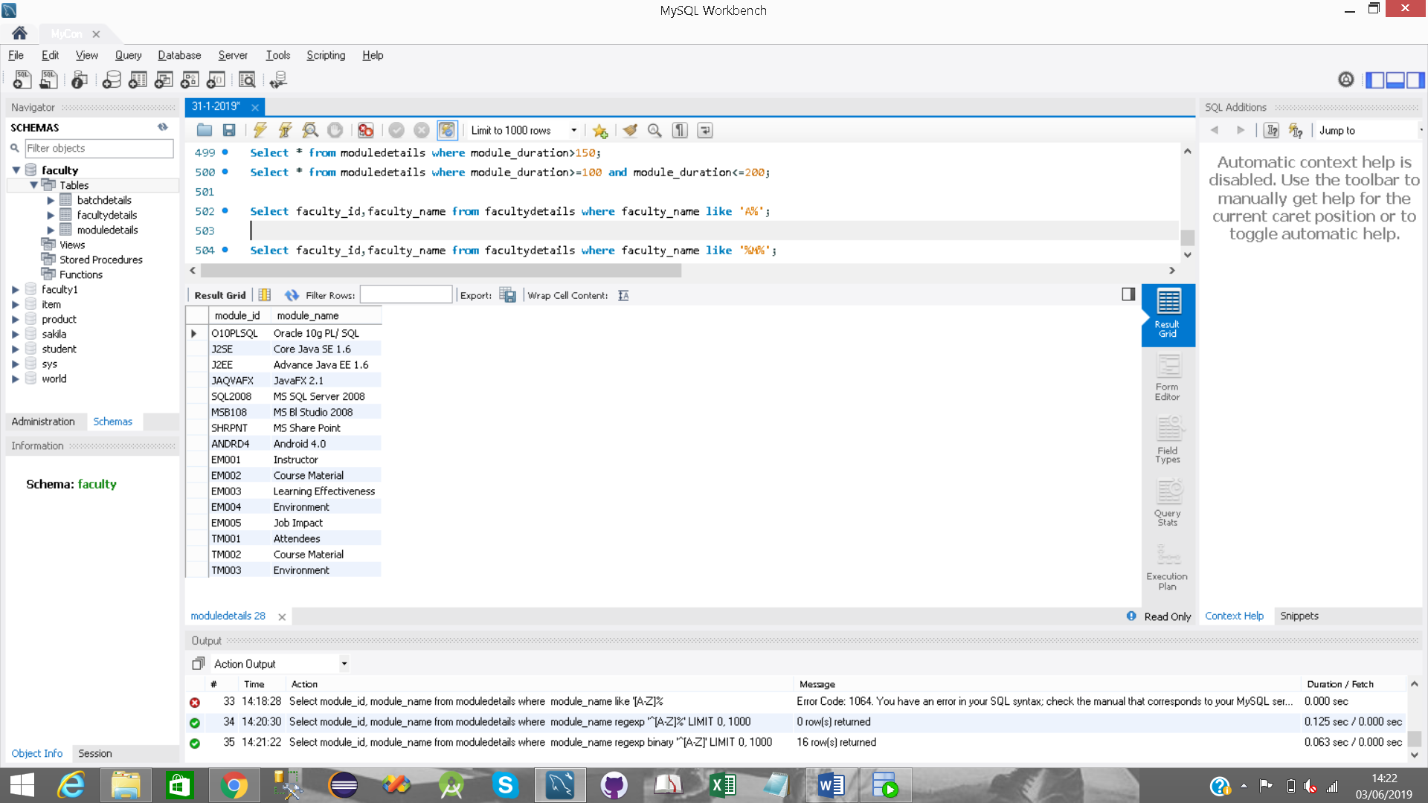

11)

Select module_id, datediff(curdate(),start_date) from student_status;

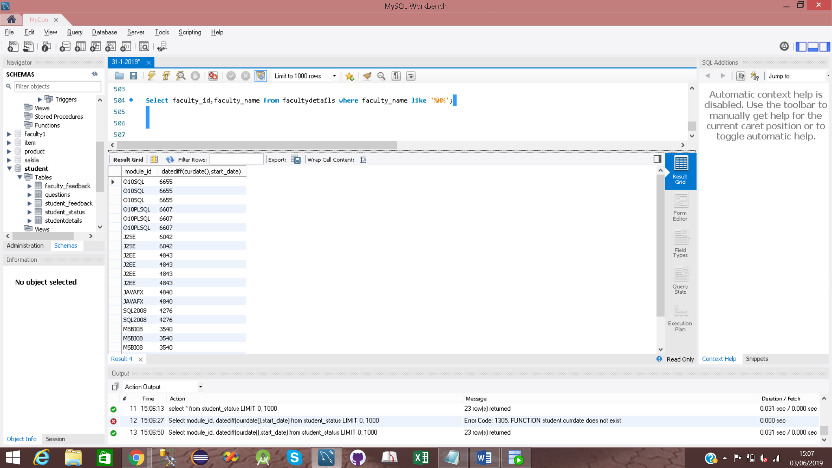

12)

select concat('Module_id is ',module_id ,' Module_name is ',module_name) from moduledetails;

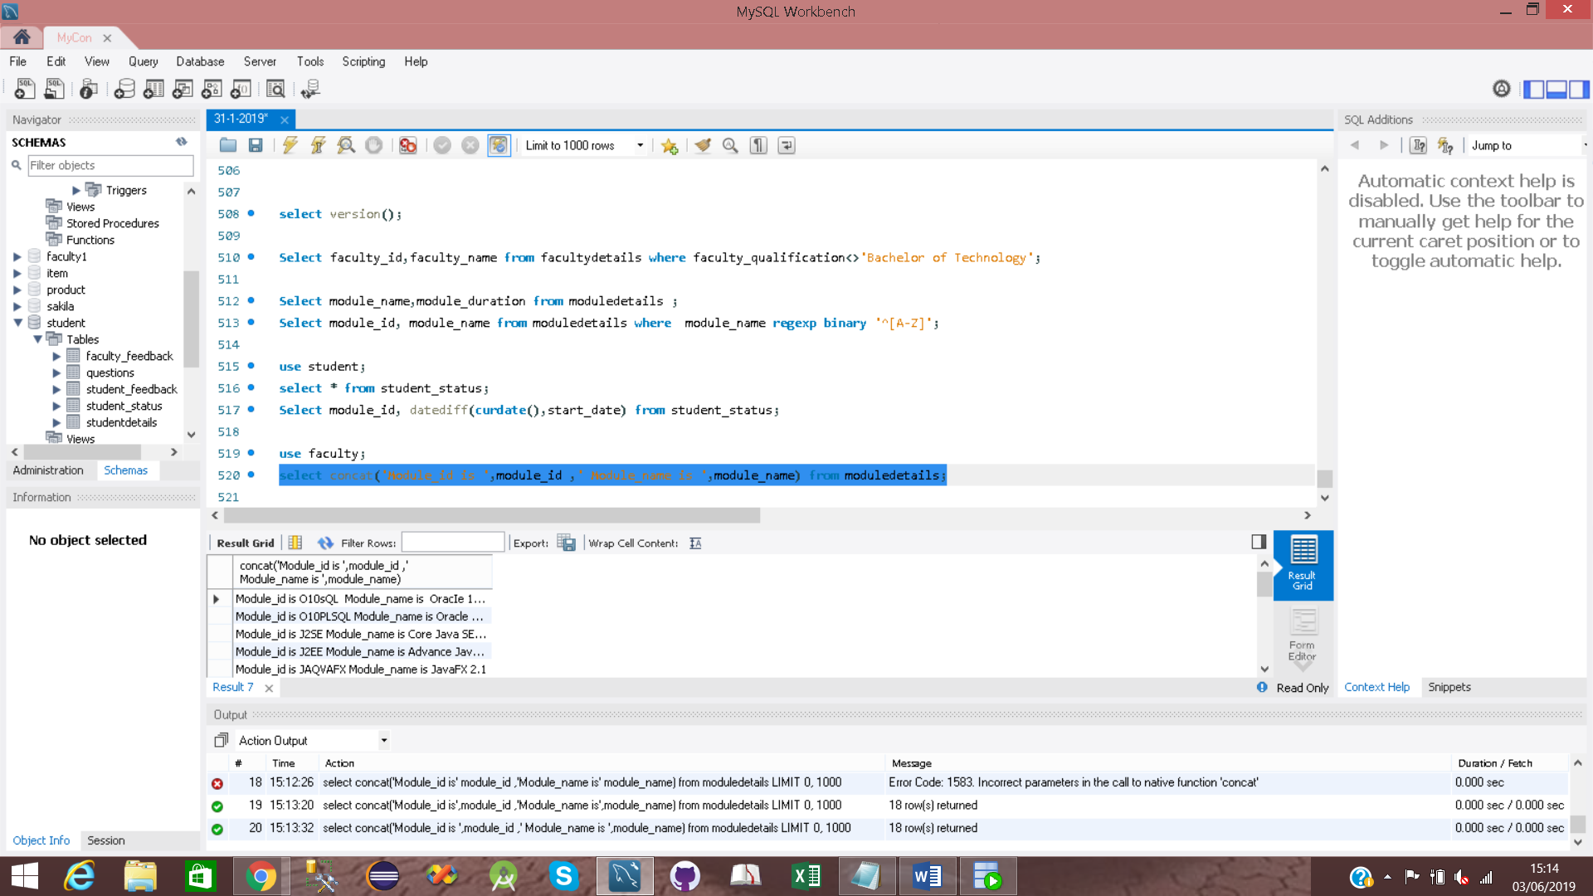

13)

select upper(module_name) from moduledetails;

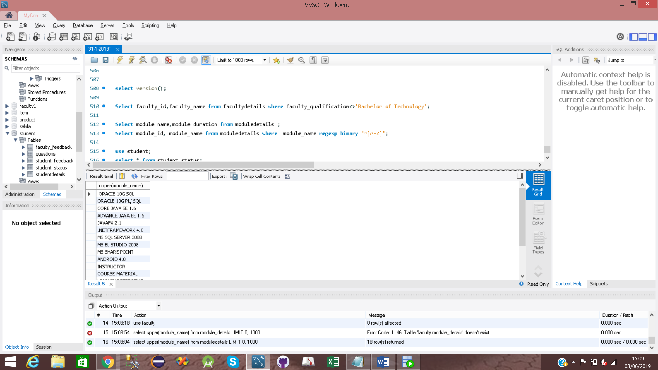

14)

select substring(module_name,2,4) from moduledetails;

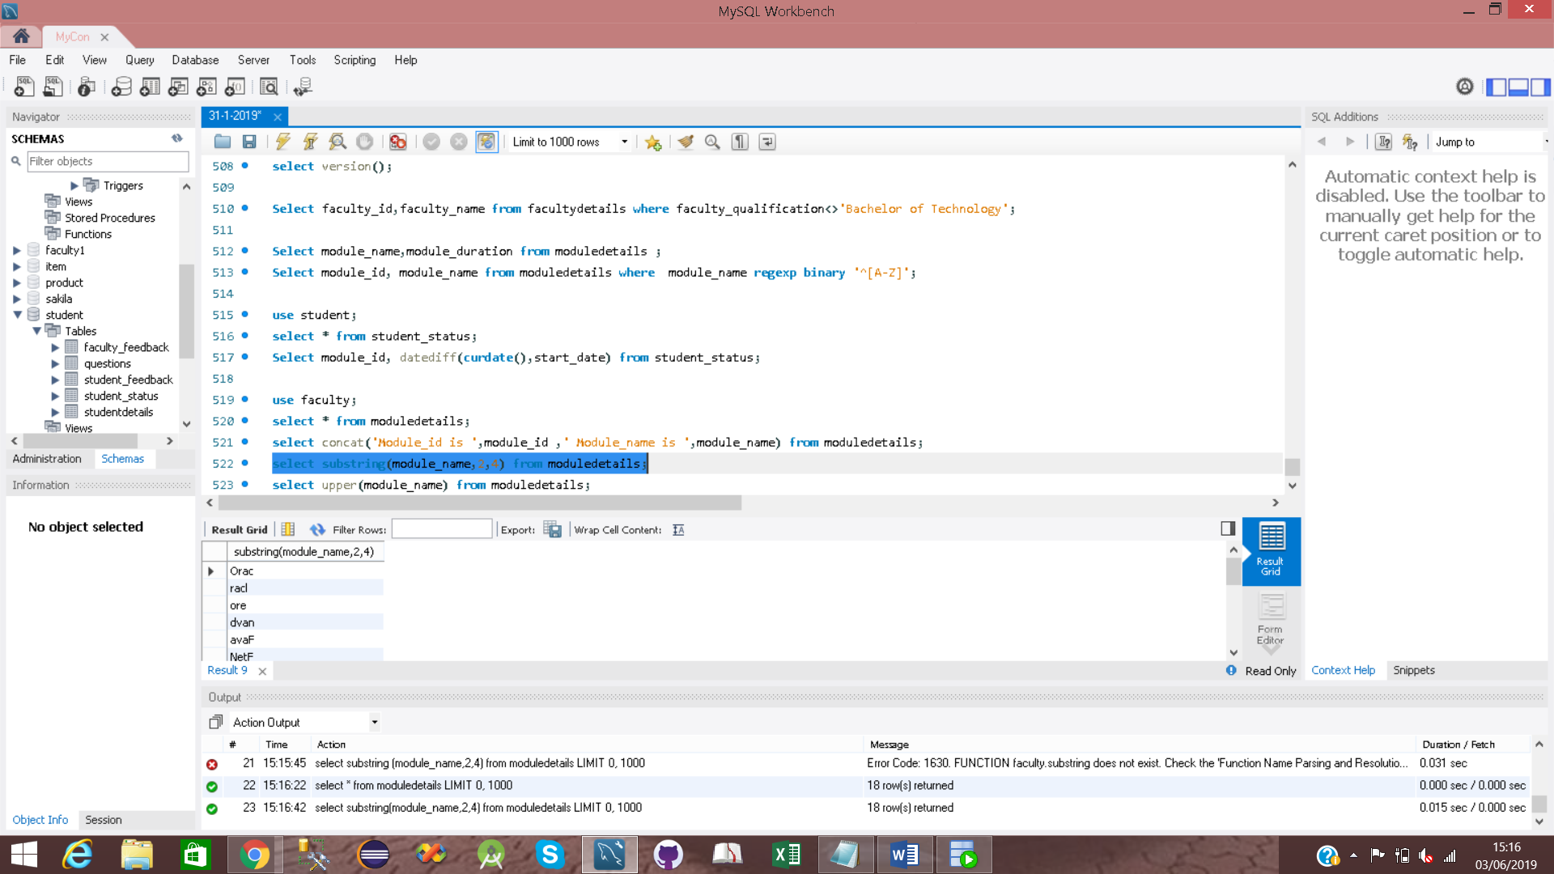

15)

select avg(module_duration) from moduledetails;

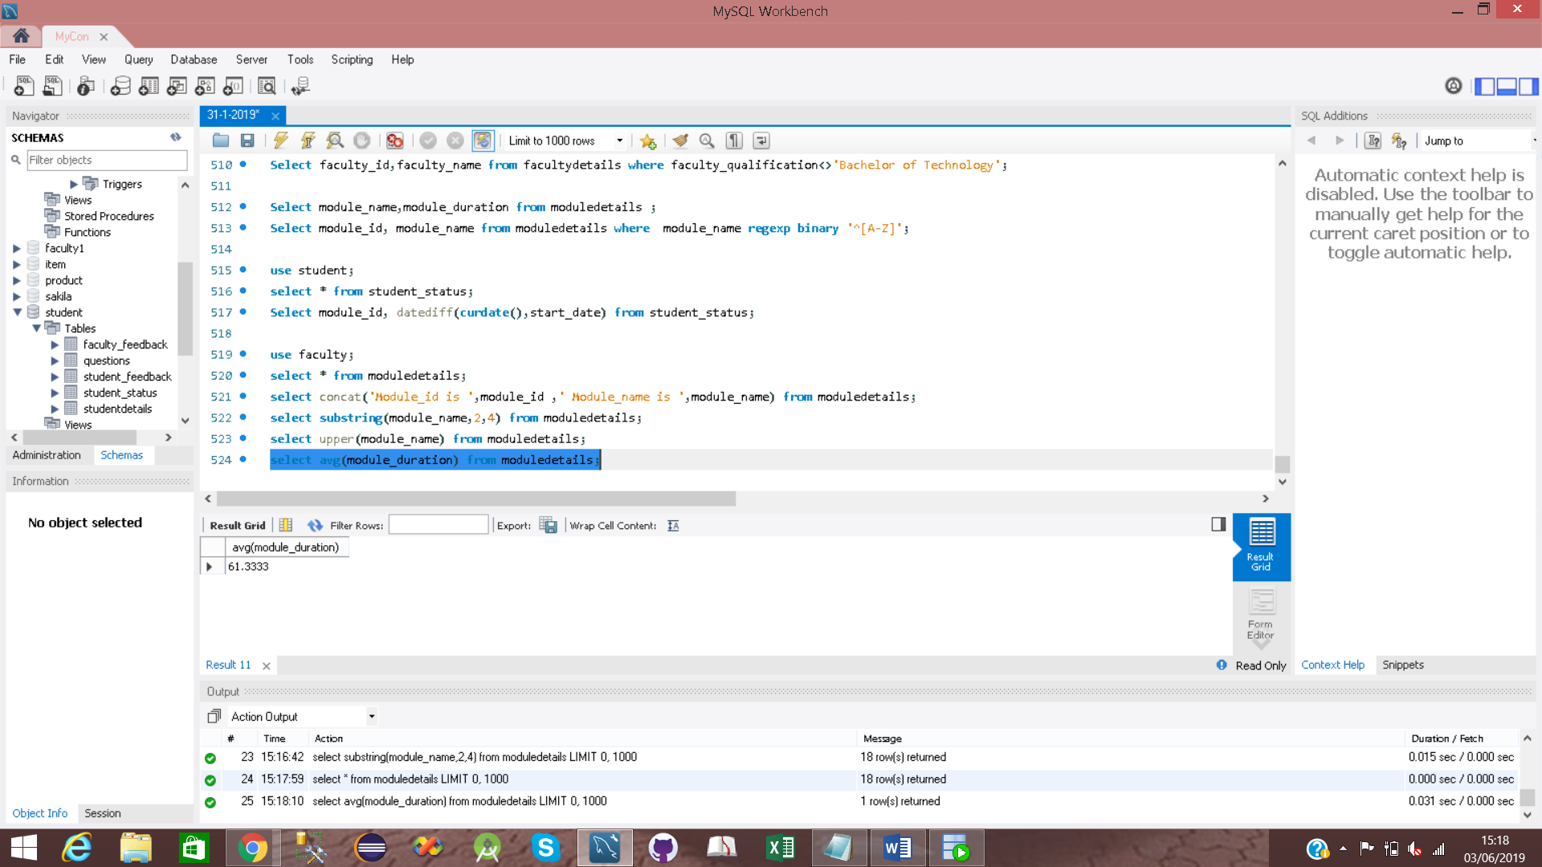

16)

select count(*) from studentdetails;

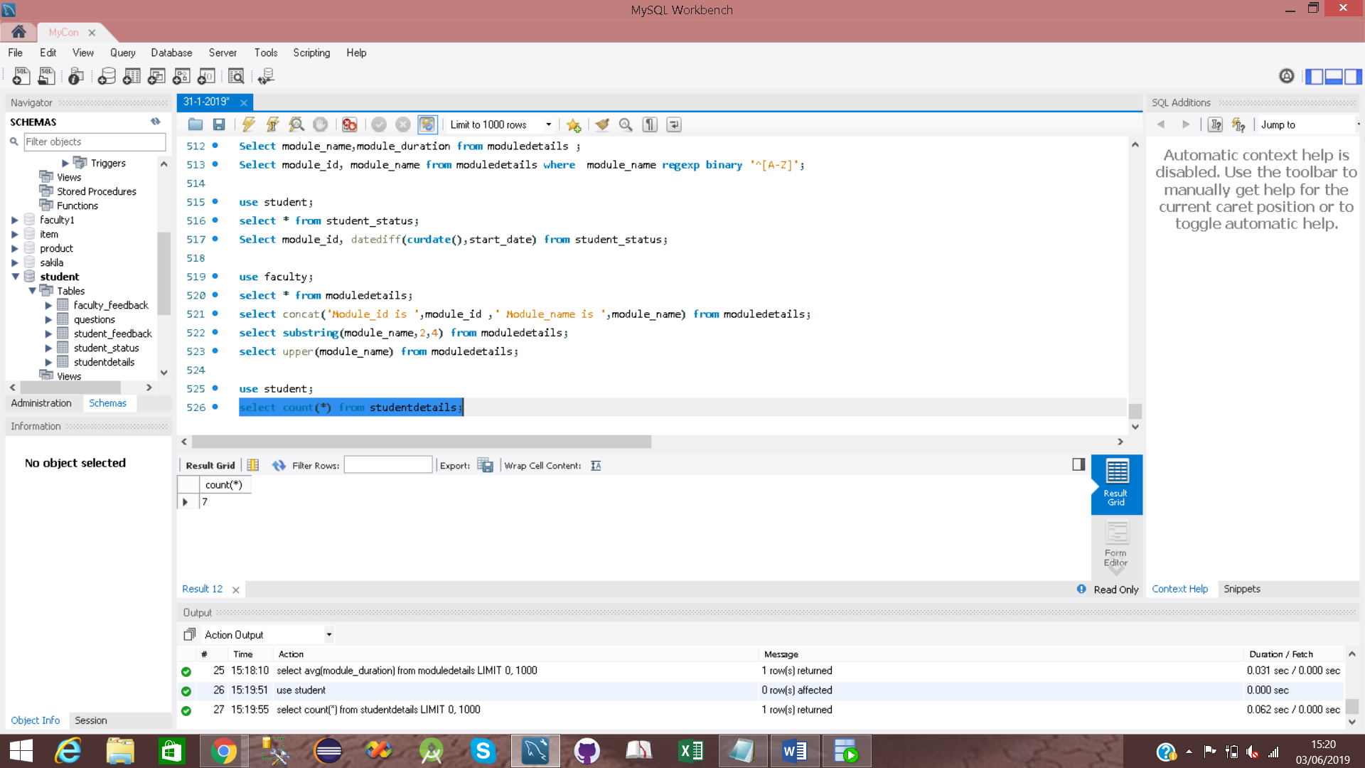

17)

select count(faculty_email) from facultydetails where faculty_email=null;

